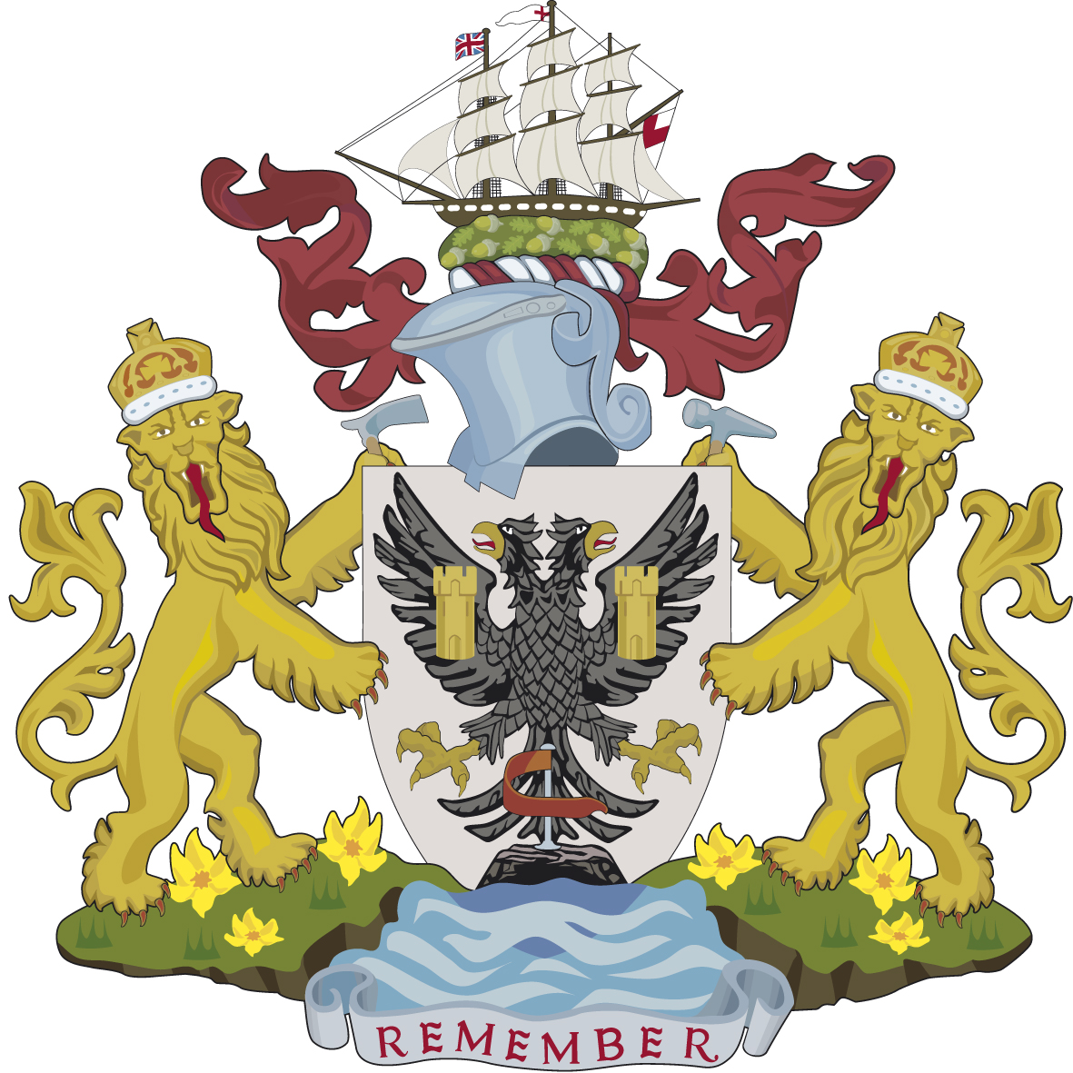

Falmouth Town Council “Town Team” Apprentice.

2 year Property Maintenance Operative Apprenticeship.

Pay: In line with the National Apprenticeship Scheme.

**Background:** Falmouth is Cornwall’s leading south coast resort it is one of the country’s largest, vibrant and most diverse towns, it is the home to Cornwall’s rich maritime heritage, the Tremough Campus of the combined Universities of Cornwall, the internationally renowned Art Gallery and many gardens of a sub-tropical theme.

Falmouth covers an area of 776 hectares with a residential population of 21,385.

Falmouth Town Council (FTC) is seeking to recruit a suitable person to train in all areas of property maintenance and compliance testing

**The vision:** The Town Team will offer the flexibility to be both proactive in their approach by working with Council Members, officers & community groups to deliver improvements within the town as well as being reactive to bring about a speedy resolution to defaults and issues. The team will strive for excellence in areas of maintenance delivered in a sustainable manner; these areas will include the upkeep of Council buildings, public toilets, play areas, sports facilities and public gardens. The Town Team will be a concise, effective unit of multi-skilled people able to compliment, support and cover each other’s duties.

Working together with Cornwall Council officers and devolution team, it is the desire of the Town Council to achieve an increased level of responsibility and a programmed enhancement for a range of assets within the town currently managed by Cornwall Council by embracing Cornwall Council’s devolution policy, delivering sustainable services locally through the directly employed Town Team.

**About you:** The Town Council are looking to recruit an apprentice to work as part of the town team; you should be able to demonstrate a passion to learn to be capable of undertaking a range of duties including(but not limited to;) property repairs, facilities compliance testing, grounds maintenance operations, facilities cleaning, minor construction, event marshalling, hard and soft landscaping works; with the flexibility to work on evenings and weekends where the needs of the Council require you to do so.

You will be required to attend Camborne College on day release to complete a Property Maintenance Operative Apprenticeship Level 2, this will require a minimum proven academic achievement of GCSE grade “C” in English & Mathematics, a mature attitude accompanied by the self-discipline to evidence the tasks needed to complete the module units whilst at work and add them to your student portfolio in your own time. On the job training will be given as well as formal training at the college.

You will be aware of your responsibility under Health & Safety law, taking reasonable care of yourself, your colleagues, other contractors and members of the public at all times whilst at work, you should be familiar with the process of risk assessment, comply with safe systems of work. Whilst carrying out your duties, you will need good communication skills, being polite and courteous, you will be aware that you represent the public face of the Council and should conduct yourself with dignity and professionalism at all times.

You should actively promote and share the vision of the Town Council to enhance the town’s assets by being physically fit, willing and able to work to the highest standards, as a valued member of the team you’ll be expected to contribute with positive ideas and suggestions.

It will be an advantage to be able to demonstrate an existing passion for learning and previous experience of working in the sector.