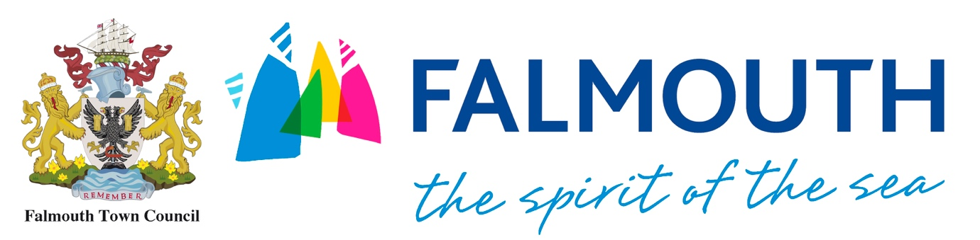

HOW TO BECOME A STALLHOLDER
Weekly Market on The Moor
Anybody wishing to trade at The Moor Weekly Market must obtain an Market Application Form from Sarah Walker (sarah@falmouth.co.uk or 01326 313553). This is available on the Falmouth Town Council website. The application form must be fully completed together with:
- A copy of your current Public Liability Insurance policy (to the value of £5,000,000)
- A completed risk assessment (please ask for copy of template if needed)
- Food Hygiene Certificate (if dealing with food)
Receipt of the application form and this documentation will be acknowledged and if possible an indication given of the availability of the market stalls. If a pitch is not immediately available, the details of registration with be held until a vacancy arises.
Agreement to trade on The Moor will only be issued once all the information has been given to The Council. Once an agreement has been confirmed, you will be given a Traders License for The Moor which you will need to read, sign and return.
Falmouth Town Council hires gazebos at an additional cost. The hire includes set up and take down of the gazebo, but does not include tables or display equipment. Please see ‘Gazebo Hire Terms and Conditions’ for more information on this service.
Fees
Standard stall space (3x4.5m) is charged at £10 per day
Gazebo stall space (3x4.5m) is charged at £20 per day
Street Food space is charged at £20 per day
Fees need to be paid to Falmouth Town Council on receipt of application to trade.

The Moor Traders License
All Street Traders need a license from Falmouth Town Council to trade on The Moor. You will be asked read, sign and return this license agreement along with all relevant documentation once your application to trade has been accepted.
On receipt of your Traders License application, we will send you confirmation and return the signed license agreement, at which point you can commence trade on The Moor.

